Sarah Tayyab

212902

BSCS-7A

**Advanced Programming Assignment 01**

**Open Source Software**

**PrestaShop 1.7.6.1**

PrestaShop is an extremely feature-rich, free, open-source ecommerce solution that you can use to operate stores in the cloud or via self-hosting.

PrestaShop has over 300 built-in features to manage product listing, payments, shipping, manufacturers and suppliers.

PrestaShop utilizes a web template system that enables users to customize shop topics and add fresh characteristics through module add-on.

**Installing prestashop:**

**Step 1:** First Install WAMP or XAMP server on your computer.

**Step 2:** Download the PrestaShop files and place it inside your “www” folder inside wamp files.

**Step 3:** Open PrestaShop through your local server host.

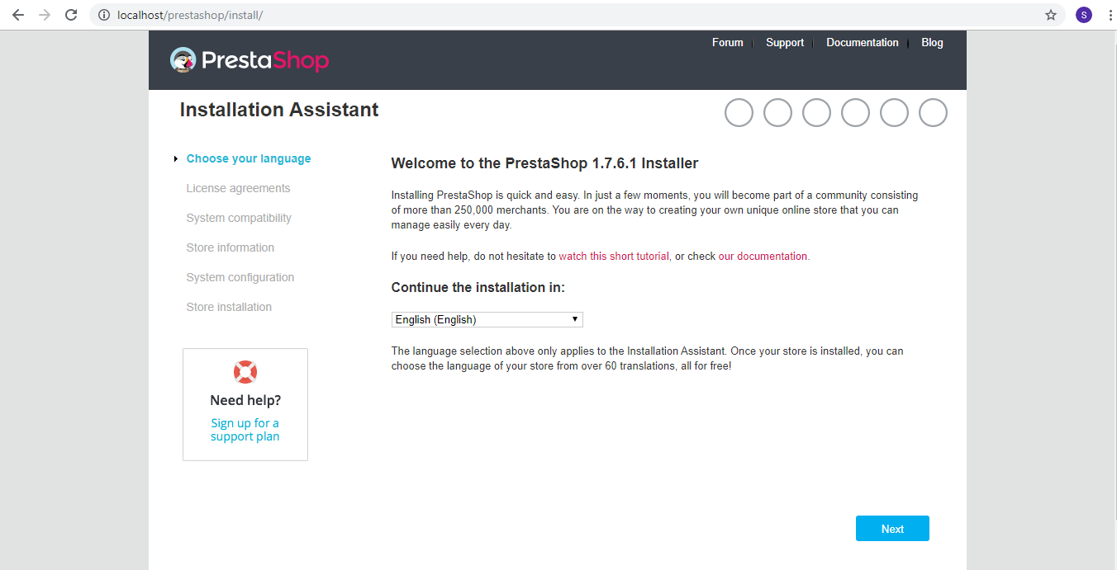

**Step 4:** Follow the installation assistant steps to install PrestaShop on your local host server.

**Step 5:** Create a database on phpMyAdmin, the installation process will itself generate query and create tables and the entire schema in that database.

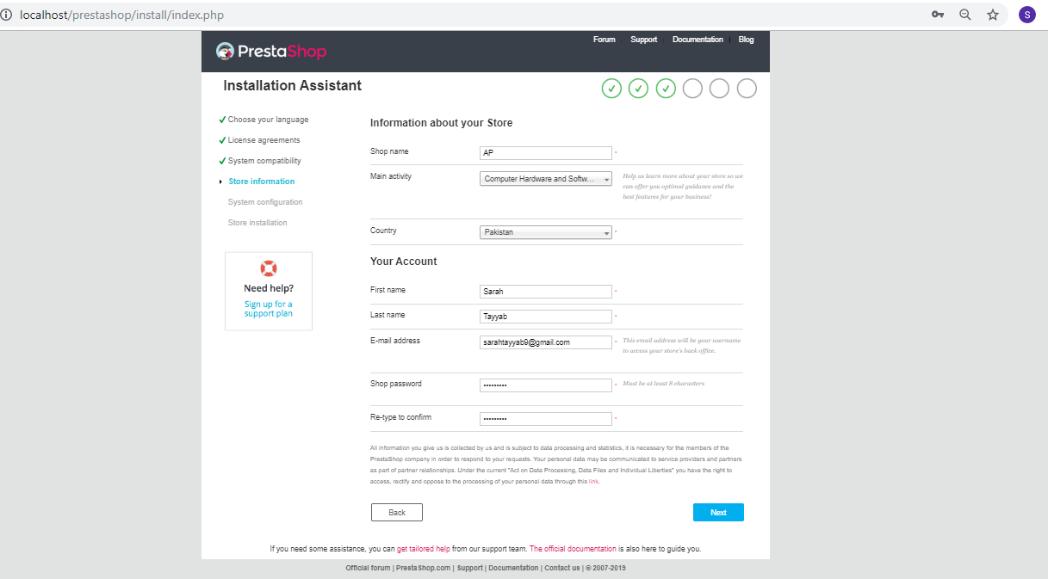

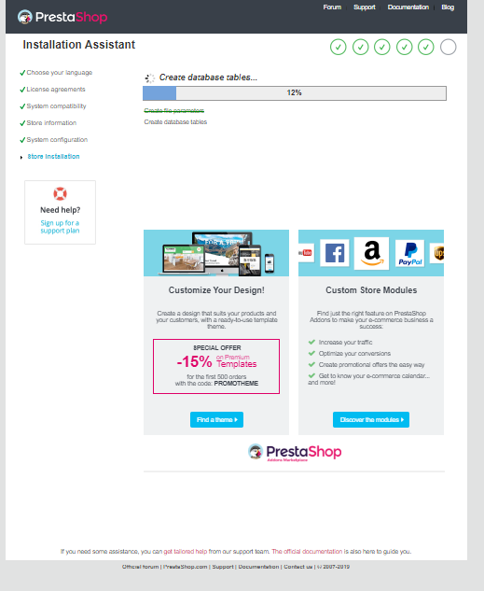



**Step 6:** Once the installation process is finished, start exploring the Software.

**Exploring PrestaShop:**

Users perspective:

Back end view:

* The dashboard feature gives an overview of the whole website by having features like site visits and net profit etc. 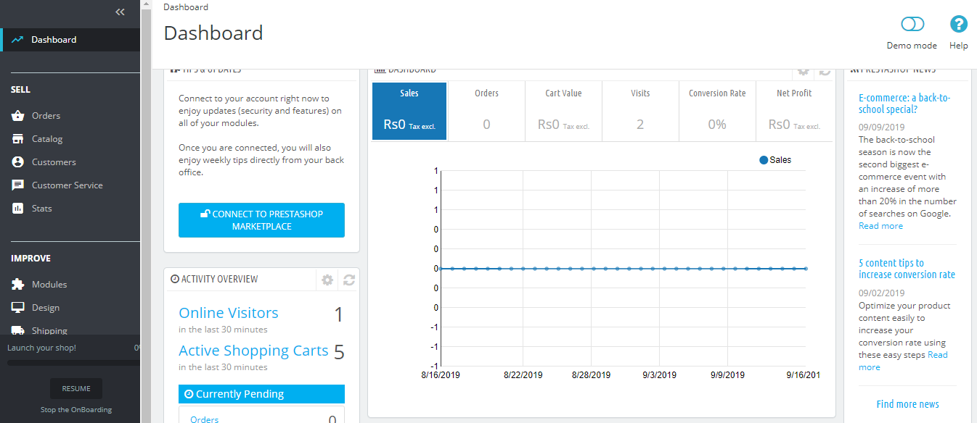
* Here are some other features of the backend view:

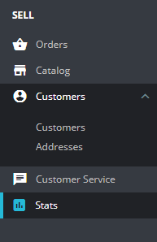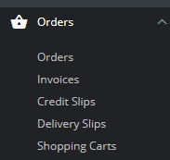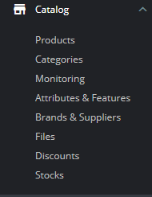

* The sell category has the attributes like orders, which keeps track of the buyers and sellers’ exchanges, and attributes like catalog that consists of all the information related to the available products. Similarly, the stat attribute gives an overview of the registrations, and buyers and sellers currently involved.
* Using the improve feature, we can manage the modules.
  + Modules are same as plug-ins in Wordpress. Modules provide additional functionalities which makes the software easier to use. PrestaShop has around 3000 modules.

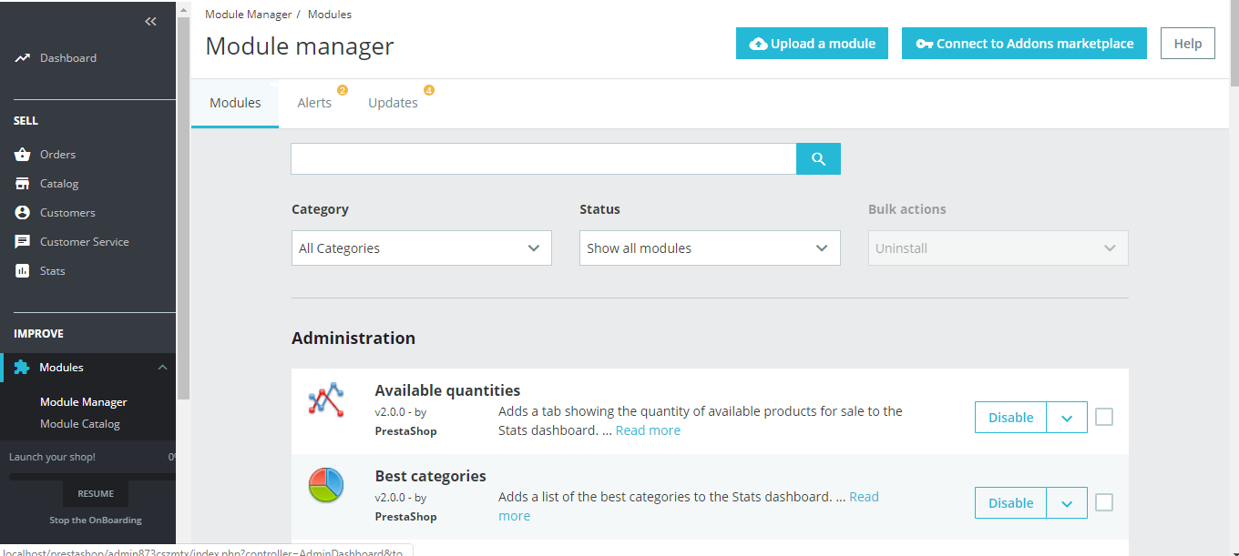

* We can add a module of our own choice using upload feature:

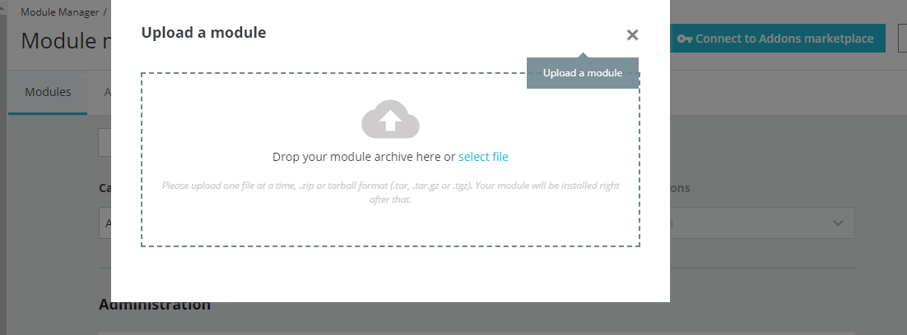

* We can install a module from given modules:

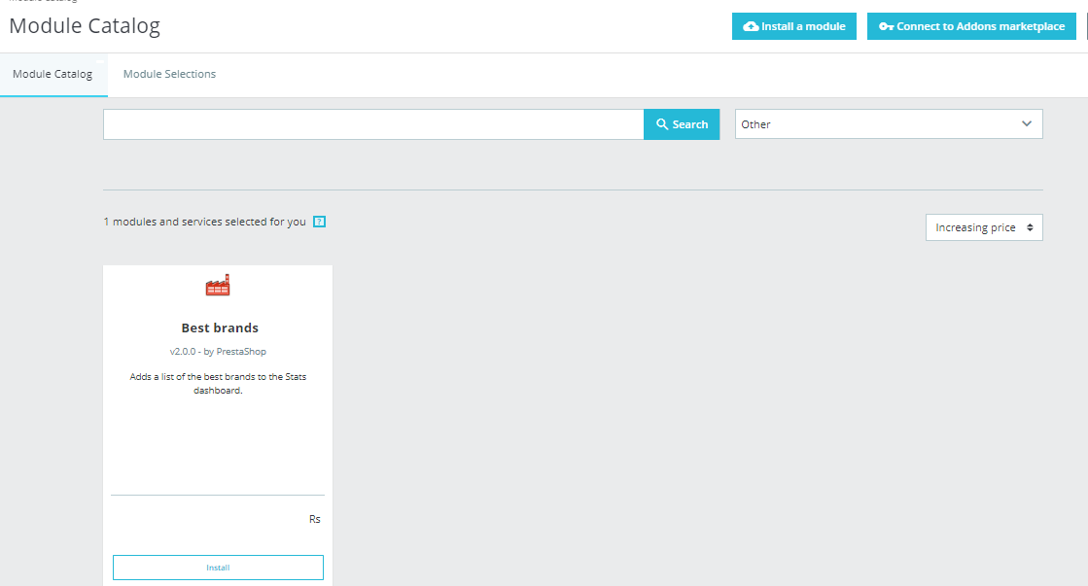

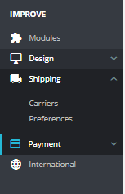

* Given above in the snapshot are other attributes that could be modified under the improved feature.
* The configure feature enables users to configure their own store preferences, such as order settings, product settings, client settings, traffic and SEO.

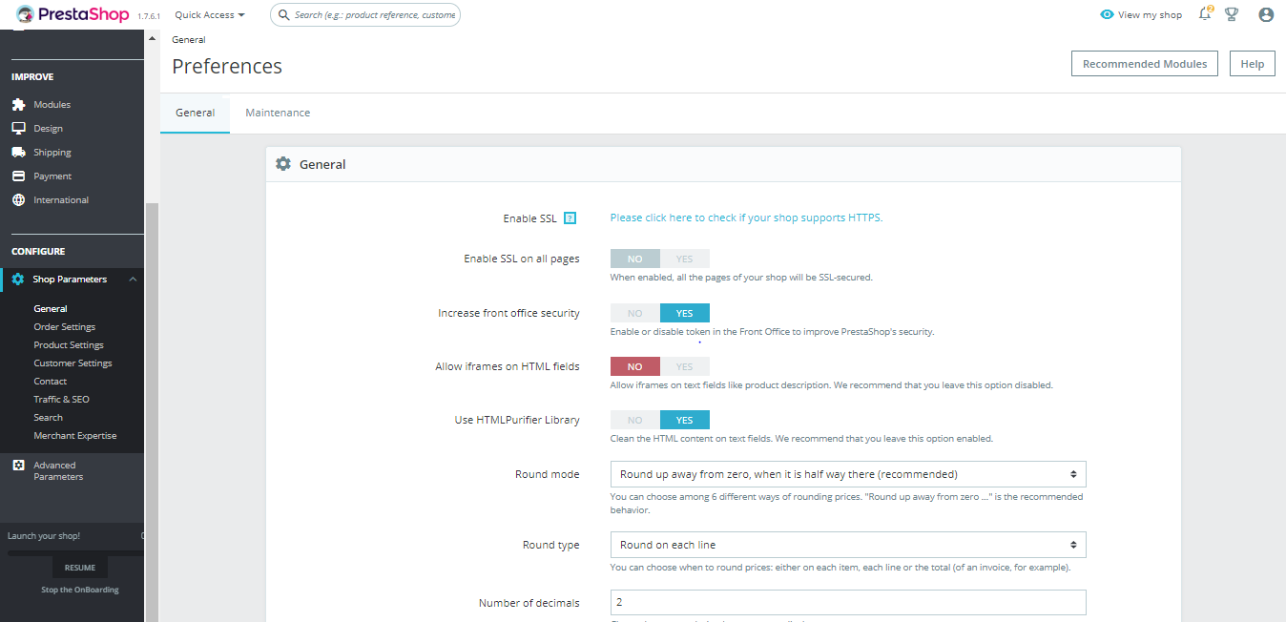

Front end view:

The modules used and the features modified in the backend could be seen here:

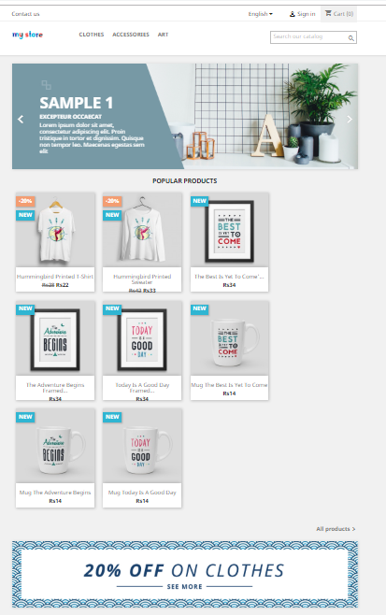

**Database Developer Perspective:**

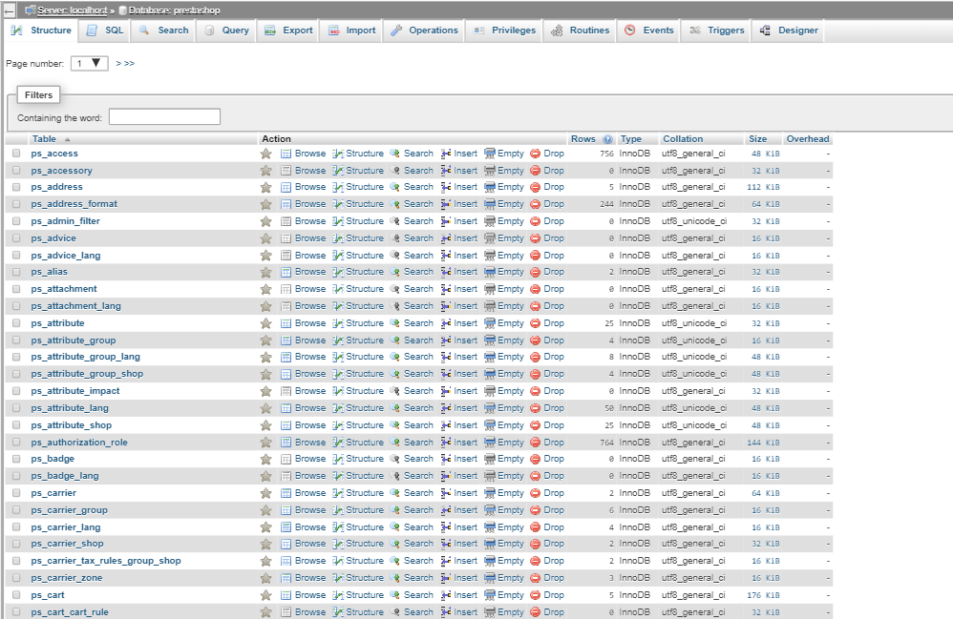

* The database has 250 tables.
* It can be modified by either using phpMyAdmin, we can add new tables, or we can add keys, or we can drop tables.
* We can also modify database by using SQL queries, we can do that by using PrestaShop feature ‘configure>advance parameters>database’:

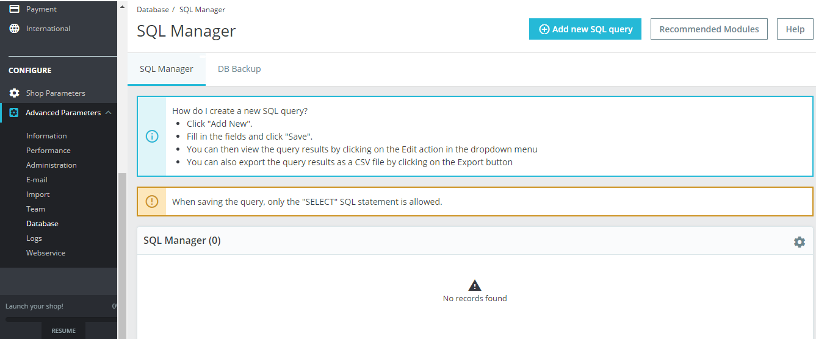

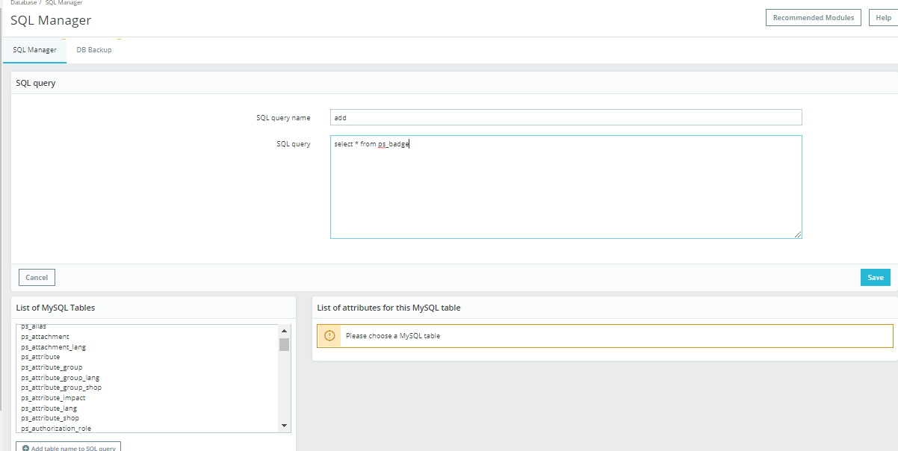

**Coder’s Perspective:**

Entire coding for Prestashop is in php. Download the theme, edit the theme and then upload it to edit your child theme:

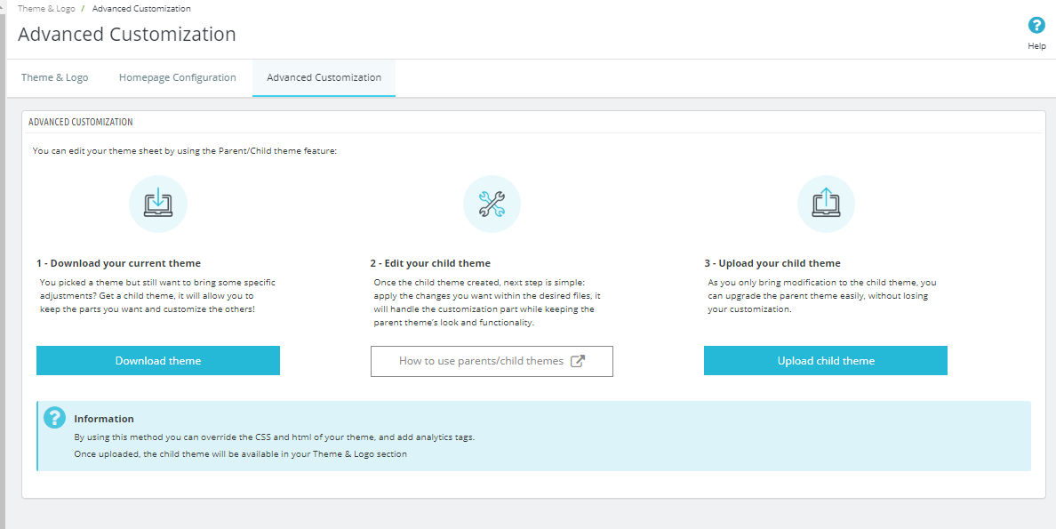

PrestaShop uses OOP concepts, create a php file for a module and enter the following code consisting of a predefined class by PrestaShop :

if (!defined('_PS_VERSION_')) {

exit;

}

class MyModule extends Module

{ }

Building a custom module:

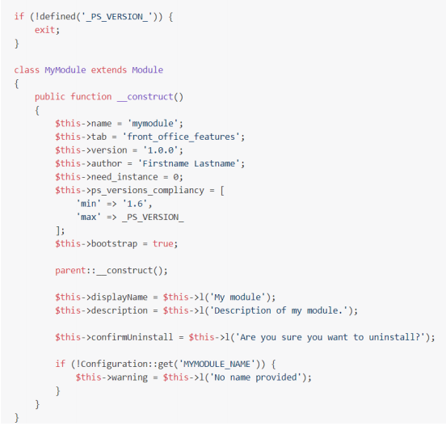

The constructor class is the first method to be called in the case of PrestaShop when the module is loaded.